H.T No
Regulations:
A18

Sreenidhi Institute of Science and Technology
(An Autonomous Institution)
Code No: 7F302 Date: 19-Dec-2022 (FN)

B.Tech II-Year I- Semester (A18) Special Supplementary Examination - December-2022
DISCRETE MATHEMATICS (CSE and IT)

Time: 3 Hours Max.Marks:70

Note: a) No additional answer sheets will be provided.
b) All sub-parts of a question must be answered at one place only, otherwise it will not be valued.
c) Missing data can be assumed suitably.

ANSWER ANY 5 OUT OF 8 QUESTIONS. EACH QUESTION CARRIES 14 MARKS.

Bloom's Cognitive Levels of Learning (BCLL)
Remember | L1 | Apply | L3 | Evaluate | L5
Understand | L2 | Analyze | L4 | Create | L6

 |  |  | BCLL | CO(s) | Marks
1. | a) | Obtain principal disjunctive normal form of the following formula.  P˅(~P→(Q˅(~Q→R))) | L3 | CO1 | [7M]
 | b) | Show the following equivalence without truth table.  (((P˄Q˄R)→C)˄(R→(P˅Q˅C)))⬄(R˄(P↔Q))→C | L3 | CO1 | [7M]
2. | a) | Prove or disprove the validity of following arguments using rules of inference.  All naughty kids are intelligent.  All boys are naughty.  Therefore all boys are intelligent. | L3 | CO2 | [7M]
 | b) | Prove that the following argument is valid:  ¬∃x (p(x)˄ q(x))  P(a)  ∴¬q(a) | L3 | CO2 | [7M]
3. | a) | Let x={1,2,3} and f, g, h be functions from x to x given by f={(1,2),(2,3),(3,1)} g={(1,2),(2,1),(3,3)} h={(1,1),(2,2),(3,1)} Find fog, foh, fohog, goh | L5 | CO3 | [7M]
 | b) | Write about partial ordering and total ordering relations. | L1 | CO3 | [7M]
4. | a) | Find midterm of (3x-1/x)⁸. | L5 | CO4 | [7M]
 | b) | Find the term which contains x¹¹ and y⁴ in expansion of (3x³ +2xy² +z³)⁵ . | L5 | CO4 | [7M]
5. | a) | Solve recurrence relation a_{n}=3a_{n-1}+2a_{n-2} for n>=2 ,a₀ =1,a₁=2. | L3 | CO5 | [7M]
 | b) | Using generating function find a_{n} in terms of n if a₀=1,a₁=2 and a_{n+2}=4a_{n+1}-5a_{n} for n>=0 | L3 | CO5 | [7M]
6. | a) | Determine whether given pair of graphs is isomorphic.  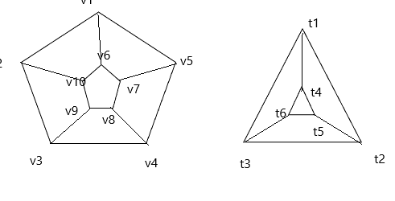 | L5 | CO6 | [7M]
 | b) | What is Euler circuit or path? How do you determine whether a graph has Euler circuit. | L5 | CO6 | [7M]
7. |  | Write short notes on:
 | a) | automatic theorem proving. | L1 | CO1 | [5M]
 | b) | Rules of Inference. | L1 | CO2 | [5M]
 | c) | Homomorphism. | L1 | CO3 | [4M]
8. | a) | Discuss in detail about automatic theorem proving. | L3 | CO4 | [7M]
 | b) | Explain about Free and Bound variables. | L2 | CO5 | [7M]
-- 00 -- 00 –

